INVITATION INTERNATIONAL FRIENDSHIP COMPETITION NORWAY 2025

Dear old and new Gymnastics Friends…

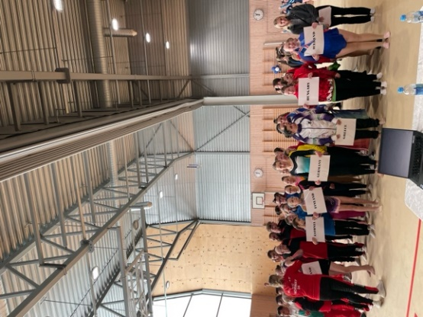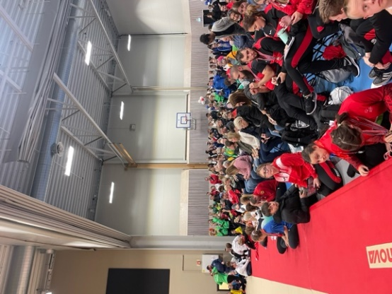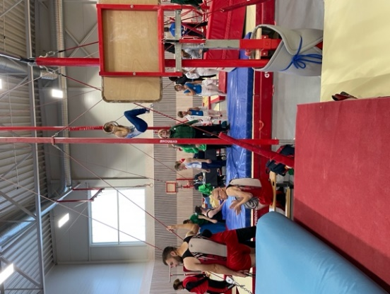

Lørenskog gymnastikklag would like to invite you to our Friendship Competition with Special Olympics rules in Artistic gymnastics, men and women, October 10th to October 12th, 2025, from 13 years of age.
We hope the Fig Para Code of Point will be ready soon. It will be used and sent to you. Para Gymnasts Classification for this competition will be on Friday (more information after nominative registration).

Last year we had an amazing time arranging the first International Friendship Competition in Norway. We hope you had the same experience, and we are excited to meet out old and new friends again. IFC is for Para- and Special Olympics gymnasts all over the world, A Friendship Competition.

The 10th of October it will be a training session for gymnastics. This will include gymnastic training, other activities and games for gymnasts and coaches. No devisioning this year.
On the 11th and 12th of October there will be competition for WAG and MAG (SO and Para) with 2 and 3 apparatus each day. The competition will be open for all levels: SO, Level A-4! The athletes must compete at the same level for all apparatus. Award ceremony will take place Sunday 12th of October after every gymnast has done their routine. Para is individual apparatus only and has three Levels to choose from.
Delegations may arrive on Thursday, October 9th, and depart either on Sunday, October 12th, or Monday, October 13th .

The competition hall is in Kjenn-hallen, Mailandveien 24, 1470 Lørenskog. The competition for WAG and MAG both Para and SO gymnast will be together Saturday and Sunday. You will get more information about this later.

We ask you to fill out this document and send it back to ifc2025@lorenskoggym.no if you want to join us in this year new IFC.

Hope to see you all!

YOUR OPTIONS:
Invitation to Friendship competition means that accommodation and travel expenses are to be arranged and paid by the participants themselves. Lørenskog Gymnastikklag will arrange buses for transportation from the hotel to the Gymnastic Hall. We have different options for the International Friendship Competition:

Friday 10th of October:
Training session with lunch in the gymnastic hall. Gymnastic training and activities to prepare for the competition. A day to get to know each other, both gymnast and coaches from different nations. More info to come.

Saturday 11th of October:
1st Competition Day, with lunch. Two apparatus for WAG and three apparatus for MAG (SO and Para).

Sunday 12th of October:
Second Competition Day, with lunch. Two apparatus for WAG and three apparatus for MAG (SO and Para).
Award ceremony will take place on Sunday. More information to come.

Sunday evening:
Banquet: At Thon Hotel Arena.

Option 1:
Training session with lunch Friday 10th of October. Competition fee and lunch Saturday, October 11th and Sunday 12th. And banquet; taco and disco at Thon Hotel Arena, Lillestrøm, Sunday evening.
120 euros.

Option 2:
Competition fee and lunch Saturday, October 11th and Sunday 12th. And banquet; taco and disco at Thon Hotel Arena, Lillestrøm, Sunday evening.
100 euros.

Option 3:
Competition fee and lunch Saturday, October 11th and Sunday 12th
70 euros.

Please write in under which option and how many gymnasts, coaches and parents.
Option | Gymnast | Coaches | Parents | Summary:
1
2
3

Comment:

Registration after June 15th will incur an additional cost of 50 euros.

For club and coaches:
Country:
Club:
Address of the Club:
Contact person for the Club:

Responsible coaches:
Name: | Age: | Phone number: (with country code) | Mail: | Allergy:

Comment:

GYMNASTS:

SO WAG.
Name | Date of birth | Level | Vault | Uneven Bar | Balance Beam | Floor | Allergy | Contact (parents)

Comment:

SO MAG.
Name | Date of birth | Level | Floor | Pommel Horse | Pararell bars | Horizontal Bar | Rings | Vault | Allergy

Comment:

PARA WAG.
Name | Date of birth | Level | Vault | Uneven Bar | Balance Beam | Floor | Allergy | Contact (parents)

Comment:

PARA MAG.
Name | Date of birth | Level | Floor | Pommel Horse | Pararell Bars | Horizontal Bar | Rings | Vault | Allergy

Comment:

You will get more information about where to send the music for level 3 and 4 later, and the plan of the different groups and apparatus in the future.

Judging:
All clubs are required to have a qualified judge if your club have more than three gymnastics who are competing. If this is a problem, please let us know.

Please let us know…
Time and day of fight from your nation:
Arrival at Gardermoen:
Flight number:

Departure day:
Time of flight from Gardermoen:
Flight number:

Remember to use “Oslo Airport: Gardermoen” as airport, and not “Torp”.

Hotel:

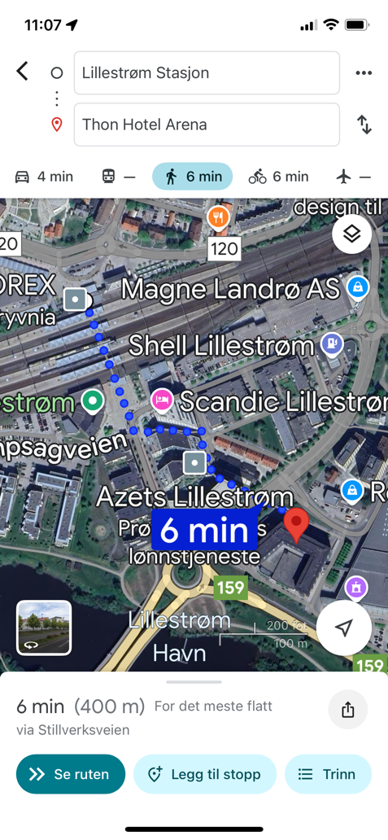
Thon Hotel Arena, Lillestrøm.
Address: Nesgata 1, 2004 Lillestrøm

Link to hotel website: https://www.thonhotels.com/our-hotels/norway/lillestrom/thon-hotel-arena/

You can choose between single- or double rooms. If you need a bigger room (more than 3 persons), please send an e-mail to: jane.andersen@olavthon.no

Single room: 1095 nok (per night).
Double room: 1295 nok (per night).
Link for hotel registration:

The hotel is in the middle of Lillestrøm, a small city in Norway. It´s a five minutes’ walk from the train station to the hotel.

The place of the hotel makes it possible for you to get an easy trip to Oslo. Only ten minutes by train from Lillestrøm.

The hotel has a swimming pool and sauna their guest can use for free. So, bring your bathing suit!!
The hotel has “Coupons” you can buy for drinks, soda etc. You can buy Coupons at the reception.

The banquet will take place at Thon Hotel Arena Sunday night. Here it will be served taco and disco with music. We are excited!

Transportation:
From the airport you can take the train to Lillestrøm. You have different options.

Option 1: Take “Flytoget”. You can order tickets at the airport or online.
https://flytoget.no

Option 2: Download the “Vy” app.

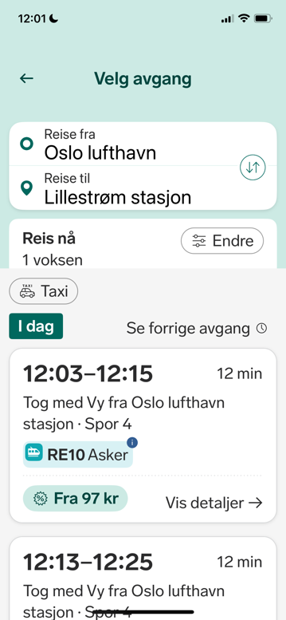
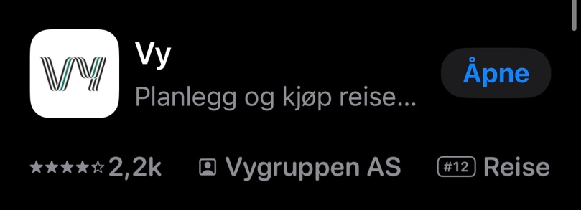

- When you open the app, you can change the language to English (under profile setting).
- You need to choose payment method.
- Go to “Search and buy”.
- Then: From: “Oslo lufthavn (Gardermoen)”, and To: “Lillestrøm stasjon”.
- See where the train will arrive in the app

You can also go to https://www.vy.no/tog/oslo-gardermoen and order your tickets online.

Option 3:
You can also ask the people at Gardermoen to help you, at the service desk. Here you can get a ticket and pay for the trip.

From the Hotel to the gymnastic hall:
Lørenskog gymnastikklag will arrange buses for transportation from the hotel to the gymnastic hall both Friday, Saturday and Sunday.

Please fill out this form and return to post@lorenskoggym.no. No later than June 1st, 2025.

We are looking forward to seeing you all!

