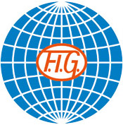
XXVIIIth Tournoi International
Combs la Ville, (France)
November 9th – November 10th, 2024

Form to be sent to:
Organizing Committee / Host Federation
Sandrine MATHIEU
3 rue louis de Funès, 77173 Chevry-Cossigny, FRANCE
Tel : +33 6 67355943
Mail: smathieu.ffgym@gmail.com
Deadline: July 8th

PROVITIONAL Nominative registration

Federation |  | Contact Person :
 |  | Phone:
 |  | E-mail:

LAST NAME | First Name | Function | Gender  M/F | Date of birth  dd.mm.yyyy

Place and date | Seal of the NF | NF authorised signature
 |  | Signature of the President or Secretary General of the participating FIG affiliated NF

