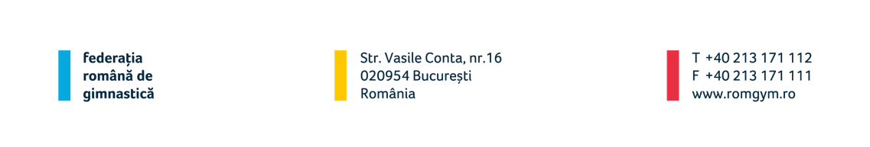

WAG International Junior Competition “Rising Stars”

Teams & Individual
17.06.2023, Ploiesti (ROU)
16-17.06.2023

Form to be sent to:
Organizing Committee / Host Federation
Contact person:
Angela Cacoveanu angela.cacoveanu@frgimnastica.com
Str. Vasile Conta nr. 16 Bucharest, sector 2
Tel. +40.21.317.1111
Fax.: +40.21.317.1112
E-mail: frgimnastica@frgimnastica.com

Deadline: 05.05.2023

NOMINATIVE registration

Federation |  | Contact person:
 |  | Phone:
 |  | E-mail:

Please fill the corresponding number for the composition of your delegation:

HEAD OF DELEGATION: _______________________

No. | Function | Name and first name
1. | Gymnast
2. | Gymnast
3. | Gymnast
4. | Gymnast
5. | Gymnast
6. | Coach
7. | Coach
8. | Medical
9. | Judge

Place and date | Seal of the NF | NF authorized signature
 |  | Signature of the President or Secretary General of the participating FIG affiliated NF

